CU CHI TUNNEL AND MEKONG FULL DAY
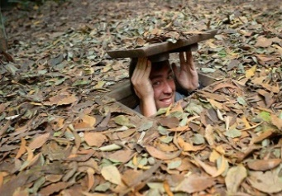
Pick-up time : 07:30 AM/End tour : 6.00 PM - Pick-up place : Your hotel in Central City
Pick-up place : Your hotel in Central City
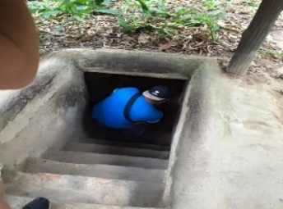
Transportation: Minivan
Join Our Group: Max 10 guests
What will you experience :
- Morning: Visiting Cu Chi tunnel
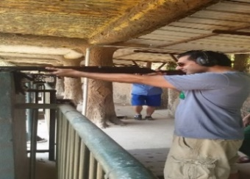
- Entering the original tunnel system
- Exploring sharpening traps in war time
- Watching documentary film
- Visiting underground kitchen room, living room…
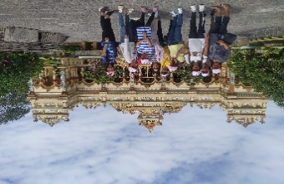
- Experience shooting.
- You have a lunch in the restaurant
- Afternoon: Visting Mekong delta
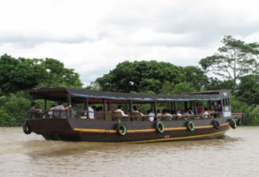
- Vinh Trang Pagoda
- Ride a wooden motor boat along Mekong river
- Visiting local villages on Dragon Island, Phoenix Island, Turtle Island
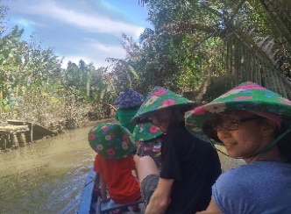
- Visit bee farm, taste natural honey, experience the feeling of carrying python…
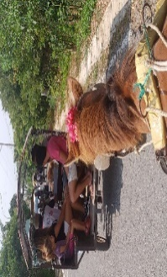
- Taking rowing boat along green and lush water coconut canal, you will see a wild natural life of Mekong Delta.
Options | Price vnd/usd |  | Inclusive | Exclusive
Deluxe Group | 1,350,000 | 58 | Car,lunch,English tour guide, entrance fee, boats, Mineral water in car. | Personal expense
- Visit coconut candy factory, handicraft workshop
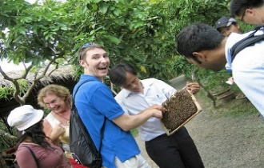
- Finally, the motor boat will bring you to the bus and drive you back to the city center in Ho Chi Minh city. Hope to see you in the next trip!

