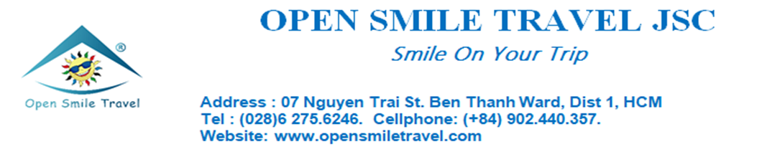
Ladies and Gentlemen, First of all, Open Smile Travel Company would like you have good health and happiness. In order for you to know detail vacation trip, we would like send a tour itinerary to you.
NAM DU ISLAND 02 DAYS 02 NIGHTS TRIP
ITINERARY
NIGHT 1 : SAI GON – RACH GIA CITY (OVERNIGHT IN SLEEPING BUS)
09:00 pm, Your tour guide will pick you up to depart to Rach Gia city. You take a rest in high quality sleeping bus.
DAY 1: VISITING NAM DU ISLAND (B,L,D)

Morning: You arrived Rach Gia about 06:00 am that have breakfast in the restaurant.
Then get on a speed boat to depart to Nam Du island.
Your tour guide take you to visit Cu Tron island, Tre island, Son island are located in Nam Du archipelago.
You will stay in guest house at Hon Lon island.
11:30 You have a lunh in local restaurant. Then you take a rest in your room.
02:00 pm, you continue to visit Hon Mau (Mau island) and take a look Ngang island which boat passed on the way. You will see people living here.
Next to drop by Bac beach to have free time for seabath….
After 01half hours, you visit Hai Bo Dap island with wild scene…You have free time to dive to see corals…
Next to visit Mau island….
05:00 pm, you back the guest house.
06:30 pm, you have a dinner in local restaurant with BBQ sea food. Then free time in this island by night.
DAY 02: MAU ISLAND - SEE SUNRISE - RACH GIA CITY - SAI GON (B,L)
05:00 am, you can get up to see sunrise by this island, and see local life….
06:45 am: you have breakfast.
07:30 am, A motobike trip around this Island. Visit Dat Do beach, Tien well water, sea lighthouse.
10:00 am, you check out hotel, get on boat to back Rach Gia city.
12:00 you have a lunch in restaurant.
01:00 pm you back Ho Chi Minh by bus.
09:00 pm, you arrive Sai Gon, End of services. Thanks so much and see you again.
PACKAGE PRICE
PRICE FOR ADULT | 125 USD/ADULT
FOR CHILDREN (05-09 Years Old) | 90 USD/CHILDREN

INCLUSIVE
- Bus, speed boat.
- Guest house in the island.
- Meal: 02 breakfast, 02 lunches, 01 dinner with BBQ seafoods
- Mineral water in bus, boat.
- Travel insurance max 500 usd/case.
EXCLUSIVE
- Personal expense
- Out side itinerary expense

Have A Nice Trip!

