HA NOI –HA LONG BAY – NINH BINH - SAPA - FANSIPAN – HA NOI
06 DAYS 05 NIGHTS
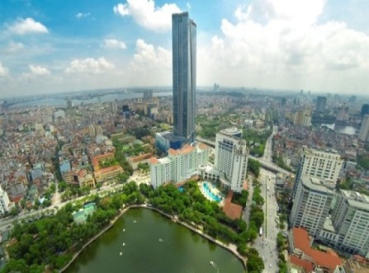
DAY 1 : PICK UP HA NOI AIRPORT - HANOI CITY TOUR
09:00 am, Your tour guide and bus will pick you up at Ha Noi aiport from your flight. and will have a breakfast at the restaurant.
We start to visit Ha Noi City with places:
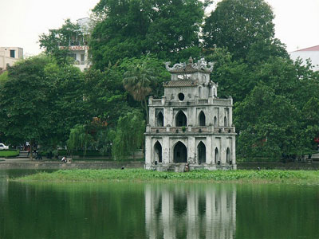
- Hoang Kiem Lake
- Van Mieu Temple
- Ancient little city (Ha Noi 36 ancient street)
- Tran Quoc temple
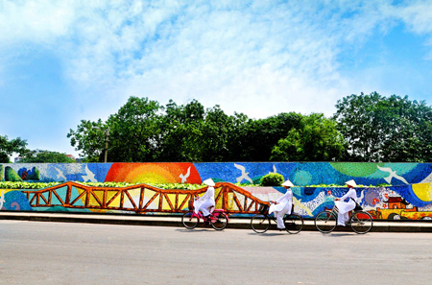
- Ceramic road
- Ha Noi Cathedral
17h00 : Take the bus come back your hotel.
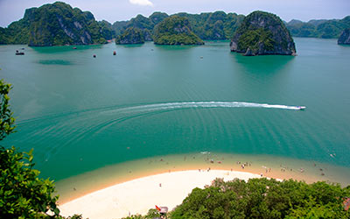
Everning: We have a dinner in the restaurant. And free time by night.
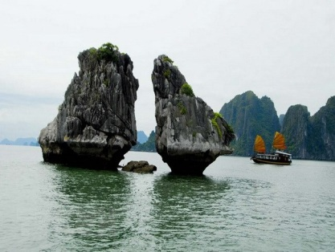
DAY 02 : HA LONG BAY – NINH BINH
7.45 - 8.15: Our bus and tour guide will pick you up at your hotel, departure to Halong bay.
10.00: We have a short break about 20 minuttes
12.00: We Arrive at Bai Chay, Halong Tourism harbour.
12.15: Transfer by tender to the Halong cruise
12.30: We start to visit Ha Long Bay.
13.00 - 14.00: We have a lunch.
14.30: Visit Thien Cung cave - one of he largest and most beautiful grottoes in Halong Bay. Its structure is complex with different levels and chambers, which contain richly ornamented stalactites and stalagmites formed millions of years ago. VisitThiencung Grotto, tourists can enjoy interesting stories about the shapes of the stalactites and stalagmites closely connected to the Halong Bay legend of King Dragon.
15.30: Enjoy kayaking around floating village, wonder daily life of fishing men on the bay.
16:30: You will return to Halong tourist wharf and going to Ninh Binh province.
19:30 We arrrive Ninh Binh.
DAY 3 : PHAT DIEM STONE CHURCH AND NINH BINH
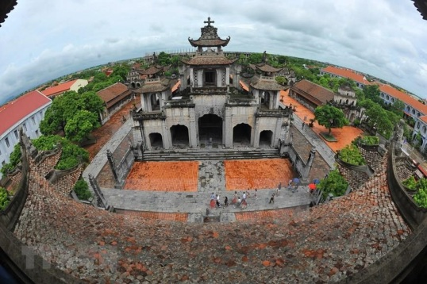
08: 00 am, after breakfast we go to visit a famous stone church is Phat Diem.
The architecture of Phát Diệm church, built in stone in 1892 is a blend of Vietnamese and European architectural styles called the "eclectic architectural style". The Cathedral was bombed on 1972 when its west wall, the convents and two of the schools were damaged; after restoration there are no tell-tale marks of this bombing. Although a church, it was built with pagoda type roofs in traditional Vietnamese temple architecture.
Then our group go to visit Hoa Lu - the Ancient Royal capital of Viet Nam. We will visit Dinh king temple and Le king temple.
in the 10th century, finding out the heroic histories of this two Kings in Chinese Wars. After that, we go to Tam Coc (10 km far from Hoa Lu).
Have buffet lunch at local restaurant.
After lunch you will get on bamboo boat - rowed by the local people - in Hoang Long river to visit Tam Coc (three caves) on the way. You pass through three enormous caves that provide a brief respite from the intense summer sun. It takes approximately two hours to go up and down the river and along the way, you witness local fisherfolk, village life along the river and, of course, the striking limestone karst formations that Tam Coc is famous for.
If you like to go biking, it is a good idea. You will have chance to visit real villages and amazing landscapes by bicycle about one hour (from Restaurant).
16.00: We take the bus come back Ha Noi.
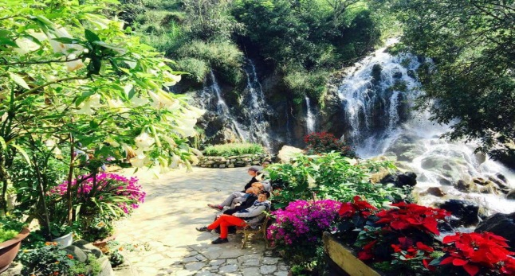
DAY 4 : HA NOI - SAPA - HAM RONG – CAT CAT VILLAGE
07h30 am, After breakfast , We will depart to Sapa
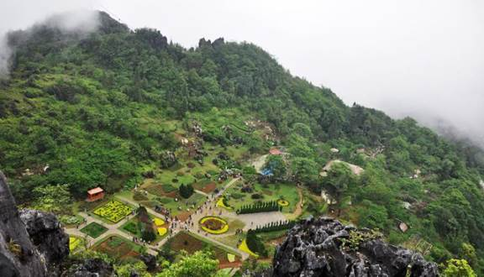
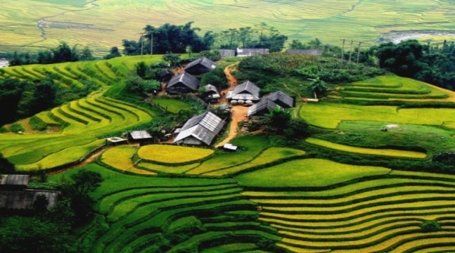
11:30 am, We arrive Sa Pa town and will explore Ham Rong Mountain with unspoiled and spectacular scenery. Here, you can enjoy many kinds of colorful flowers in Indochian Orchid Garden. Passing two Heaven Gates, visitors will reach the top of Ham Rong which is called Pitch Cloud and have a panoramic view of Sapa.
13h00 We have a lunch in the local restaurant 14h00 We start trekking to Cat Cat village which is occupied by the Black H’mong tribe. Here, you can see the hydroelectric power station which was built by the French in twentieth century. You will experience the tribal way of life of ethnic minorities while enjoying wonderful views of the terraced rice paddy fields.
We visit Love water fall in this village.
17h00: Visit Sapa Market. Then come back to the hotel. Relax.
19h00: We have a dinner, Walking around Sapa town to see local life of ethenic people and visit Sapa night market.
21h00: We come back hotel, free time by night.
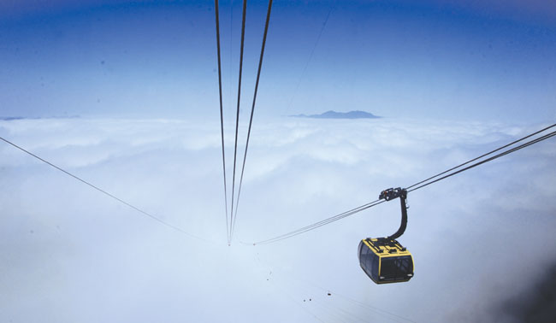
DAY 05 SAPA – FANSIPAN TOP – SAPA – HA NOI
08h00 am, after breakfast, We’re going to HoangLien Son mountain.
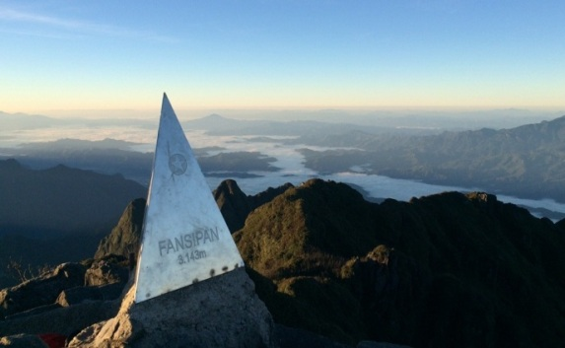
09h15 am, Our group check in Fasipan cable car. You will reach the top of Fansipan at 3,143m high after 20 minutes in the cabin.
We enjoy the fresh air and the beautiful landscapes from the high.
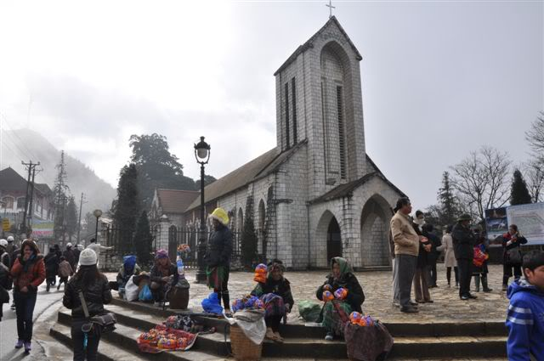
12:00, We have a lunch at the restaurant.
13h30 Next to visit Sapa stone church
14h30 We’re going to Ha Noi.
18h30 We arrive Ha Noi
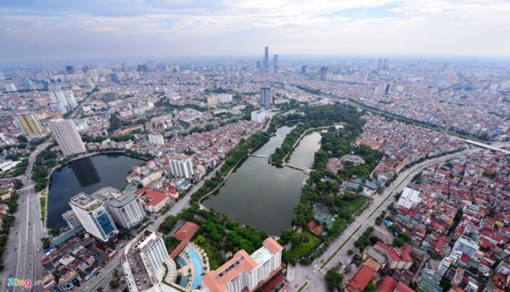
19h00: We have a dinner. Next to walk around Ba Dinh park enjoy coffee...
Second option: Bus take us to water puppet show center to watch this show (optional)
DAY 6 : HA NOI – DROP OFF TO THE AIRPORT
08:00 am, afterbreakfast we’r going to the airport to check in your flight .End of services.
INCLUSION: | EXCLUSION
Transportation  Flight tickets  Luggage: 20kg/person/way.  03-star hotel  05 breakfasts at the hotel.  05 lunches at the restaurant 01 lunch on the flight  05 dinners.  Mineral water.  Travel insurance.  Tourist hats.  Sightseeing tickets.  Fansipan cable car ticket. | Personal expenses

